Creative Brief

Emma Gindy

11/7/18

Project Title: Moon Landing Conspiracy Theory Website

1. Project Overview

The goal of this website is to teach the audience about the moon landing conspiracy theory in a convincing manner. While the topic is innately a bit humorous, I want the website to seem factual and not come across as a joke.

1. Resources

Copy is available at <https://en.wikipedia.org/wiki/Moon_landing_conspiracy_theories>. Here is another site just for you to look through to further understand the conspiracy <https://www.space.com/12814-top-10-apollo-moon-landing-hoax-theories.html>.

Photographs are available on the Wikipedia page and on google images.

1. Audience

The primary audience for this site will most likely be teachers and employers. It is not intended for young children (does not need to be overly simplified.) This is a strictly informational site.

1. Message

I’d like to focus on explaining the actual conspiracy rather than its origins. The bulk of the content on the website should be the actual reasons why people think the moon landing didn’t happen.

1. Tone

The tone should be informational. No need to adjust the copy to make it humorous or satirical.

1. Visual Style

I’m picturing a clean, relatively minimalistic black and white site using large images and clean type. Maybe one accent color. (sorry the images pasted weirdly on this doc)

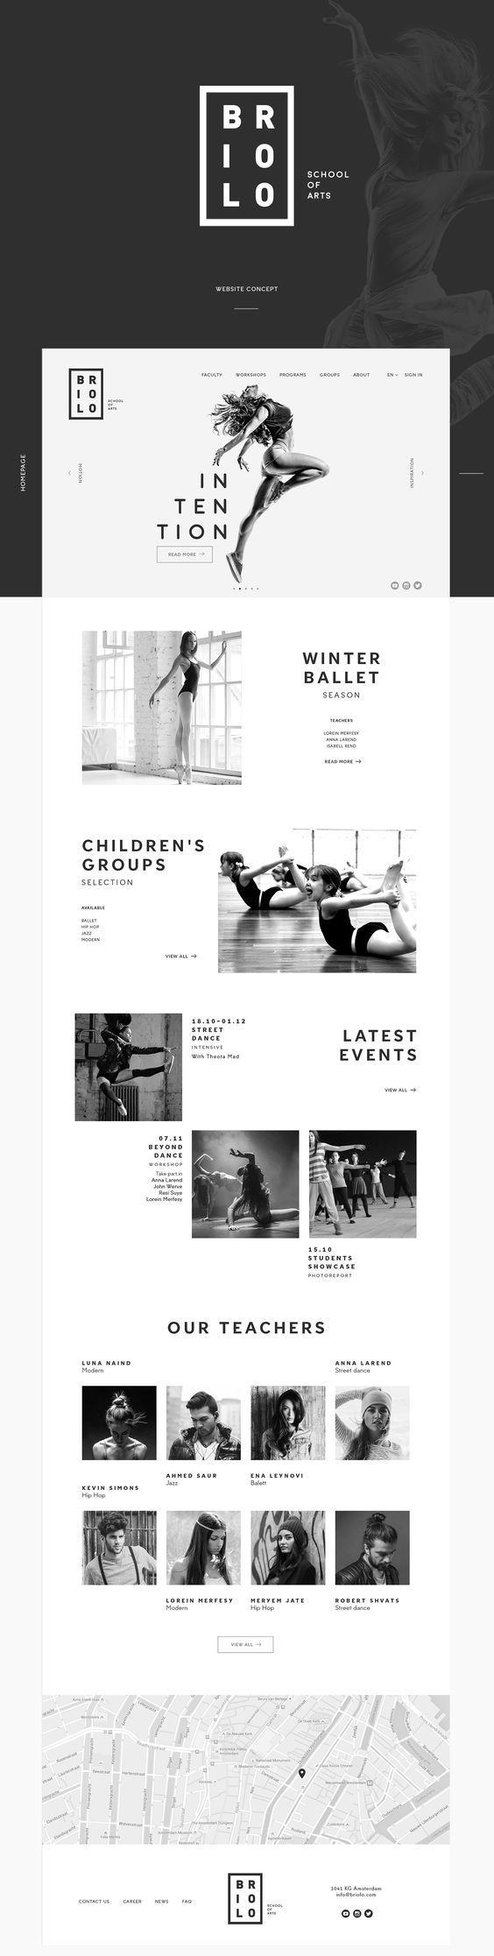

**[[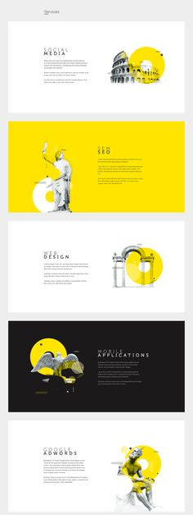](https://www.behance.net/gallery/37703399/Dottopia-web-design-UXUI)](https://www.behance.net/gallery/37703399/Dottopia-web-design-UXUI)**

**[[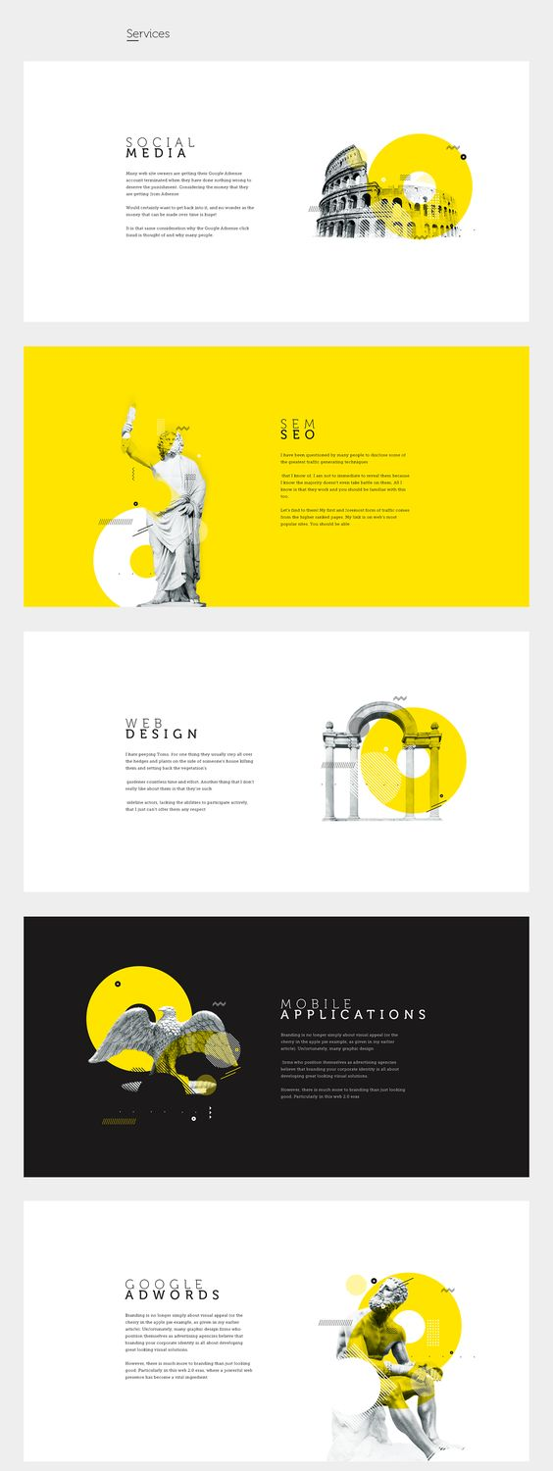](https://www.behance.net/gallery/37703399/Dottopia-web-design-UXUI)](https://www.behance.net/gallery/37703399/Dottopia-web-design-UXUI)**